
Algebras and Representations
in China and Europe

ASI/B7-301/98/679-11

Beijing Normal University, Chinese Academy of Sciences, Tsinghua University, USTC Hefei
UIA Antwerp, Universität Bielefeld, Technische Universität Chemnitz, University of Leeds, University of Leicester
Newsletter One

Contents:
Scholarships awarded
Training missions
Project regulations
Events
Website

Scholarships awarded
Five scholarships have been awarded for the current academic year. Ronghua Tan started her scholarship early in December 2002, Ming Fang, Degang Liang and Abudukade Wufu have been starting end of December 2002, and Dong Liu will start in spring 2003.
Here is some information on the winners of these awards. All of them have already demonstrated their mathematical abilities and they all received excellent references.

Dong Liu: Born 4/68, male, Yangcheng Teachers College, Bachelor degree at Nanjing Normal in 92, Master degree at East China Normal in 98, then four years of work as a lecturer at Changzhou Teachers College, (co-)author of five articles on Lie algebras (partly joint with Lei Lin and with Naihong Hu). Expertise in Lie algebras.
Chinese supervisor: Nanhua Xi (Academy), European supervisor: Claus Michael Ringel (Bielefeld).
Ming Fang: Born 11/79, male, Bachelor degree at USTC Hefei in 2001, winner of a number of scholarships. Expertise in representations of algebras and groups.
Chinese supervisor: Pu Zhang (USTC Hefei), European supervisor: Steffen Koenig (Leicester).
Degang Liang: Born 11/75, male, Bachelor degree at Jilin University in 1999, Master degree at Nankai University in 2002. Expertise in combinatorics and symmetric groups.
Chinese supervisor: Bin Zhu (Tsinghua), European supervisor: Anne Henke (Leicester).
Ronghua Tan: Born 9/76, female, Bachelor degree at Hubei Institute for Nationalities, Master degree at Hubei University, author of three articles on ring theory. Expertise in rings and algebras.
Chinese supervisor: Changchang Xi (Beijing Normal), European supervisor: Steffen Koenig (Leicester).
Abudukade Wufu (Uighur version of the name: Abdukader Obul): Born 2/63, male, Bachelor degree at Kashgar Teacher College Xinjiang in 85, eleven years of work as a teacher and then as a lecturer at this college, Master degree at Beijing Normal in 99, then again working as a teacher and then as an associate professor at Kashgar Teacher College, author of an article on Ringel-Hall algebras. Expertise in quantum groups and representations of quivers.
Chinese supervisor: Bangming Deng (Beijing Normal), European supervisor: Thomas Brüstle (Bielefeld).

Training missions
Changchang Xi (Beijing Normal) visited Leicester from October 9 to December 8, 2002; he worked with Steffen Koenig and Anne Henke. He gave two seminar talks and a talk at a workshop at Leicester, and he also gave talks at Leeds, Oxford and City University London. His visit was supported by a scheme 5 grant from the London Mathematical Society.
Dieter Happel (Chemnitz) will visit Beijing Normal University in March 2003 and will give a lecture series there on Hereditary Categories.
Pu Zhang (USTC Hefei) will visit Antwerp in February and March 2003 and then will pay a shorter visit to Leicester.
Yingbo Zhang (Beijing Normal) will visit Bielefeld in March 2003.
Changchang Xi (Beijing Normal) will visit Bielefeld from end of May to beginning of July 2003.
Claus Michael Ringel (Bielefeld) will travel to Hangzhou in October 2003.
Anne Henke (Leicester) will visit Beijing in September 2003.
Steffen Koenig (Leicester) will visit Beijing in autumn 2003.

Please note: The project has budgeted for 20 travels (`training missions’) by Chinese partners to Europe and for 20 travels by European partners to China; at least six lecture series have to be given by European partners in China.
It is vital to obtain additional funding from other sources; we need at least 100,000 Euros of additional funding for the project.
Please inform the management team of all your travel plans and of all funding which may qualify as additional funding of the project (as detailed in earlier information sent out by the management team).

Project regulations
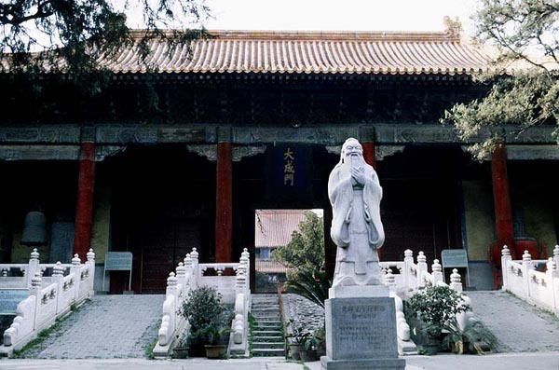

All participants of the project are supposed to acknowledge EC support whenever possible, for example in articles and on webpages. Please mention the AsiaLink project `Algebras and Representations in China and Europe’, ASI/B7-301/98/679-11, and send copies of all these acknowledgements (or articles) to the management team.

Events (in the next few months)
The next meeting of the Leicester-Oxford-Warwick study group in algebraic Lie theory will take place on January 8 and 9 at Oxford. Three Chinese PhD students will participate in this study group, which is devoted to q-Schur algebras and their application to representations of finite general linear groups in cross characteristics.
A workshop on Hochschild cohomology and applications will be held at the University of Leicester, March 30 to April 5, 2003, http://www.mcs.le.ac.uk/research/pure/HHworkshop.html.
For conferences in representation theory and related areas see the fdlist information server http://www.mathematik.uni-bielefeld.de/~sek/fdlist.html.

Website
http: //www.mcs.le.ac.uk/research/pure/AsiaLink/AsiaLink.html
Please contribute by sending us information to be posted on this website and by giving us addresses of any links appropriate. Please link this website to your homepage.
Date: 2/1/2003, Authors: Bangming Deng, Anne Henke and Steffen Koenig.

